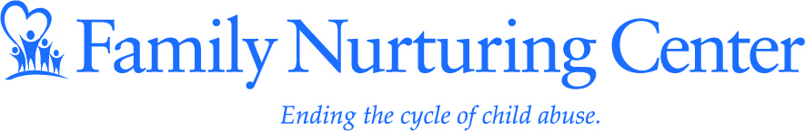

Dear Friends:

On Friday, August 24th, Family Nurturing Center will host its 24th annual fund raising gala the Blue Ribbon Bash at the Cincinnati Airport Marriott. All proceeds from the evening event benefit the child abuse treatment, prevention and parenting education services that we provide to thousands of children and families in Greater Cincinnati. The blue ribbon is the international symbol for child abuse prevention and serves as a visual reminder of the role that we all must play to prevent and confront all forms of child abuse and neglect.

Child abuse affects us all; regardless if you know of any of the five children who will be reported abused in our country in just the time it takes you to read this letter. You may know the numbers: One out of every 10 children will be sexually abused before they reach the age of 18. Chances are, you also know the victims.

Now is the time to do more than just read about the statistics. I am asking for your participation in making the Blue Ribbon Bash a success by donating a charitable in-kind gift of your choosing to include in our silent auction. This fundraiser attracts hundreds of the region’s most respected business, civic and philanthropic leaders; an excellent opportunity for you to not only reach an exceptional market, but also to help an unparalleled cause.

Tickets are $100 per guest and include a 1-hour open bar, live music with the band Swampthang, all night heavy hors d’oeuvres and of course our highly regarded silent and live auction.

The Blue Ribbon Bash is truly a Party with a Purpose – child abuse prevention. Thank you so much for your consideration of this request and for your belief in our mission to end the cycle of child abuse. Please contact me if you would like to make a donation or learn about other ways to support Family Nurturing Center.

Sincerely,
Tracy Klink
Director of Marketing and Special Events
Tracy.klink@familynurture.org
859-538-1630

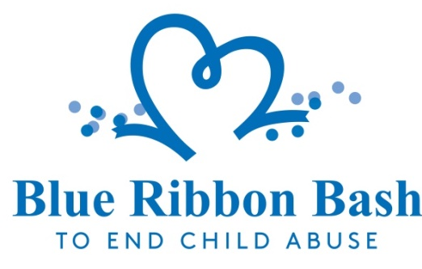

Friday, August 24, 2018
Cincinnati Airport Marriott

AUCTION DONATION FORM

Company Name __________________________________________________
Contact Name ____________________________________________________
Address _________________________________________________________
Phone number ___________________ E-mail _________________________
Web Site ________________________________________________________

Description of In-Kind Donation _____________________________________
_________________________________________________________________
_________________________________________________________________
_________________________________________________________________

Fair Market Value $_____________________

- Enclosed is my donation.
- I will deliver the donation to Family Nurturing Center (August 10th deadline).
- I don’t have an auction item, but would like to donate money to support your cause.
- I would like information about corporate sponsorship.
- I would like to purchase tickets for the Blue Ribbon Bash.

Contact Information: Tracy Klink, Director of Marketing & Special Events 859-538-1630 tracy.klink@familynurture.org

Family Nurturing Center, 8275 Ewing Blvd, Florence, KY 41042

www.familynurture.org

Thank you for helping us in our efforts to end the cycle of child abuse by promoting individual well-being and healthy family relationships.

