Mad? Walk away, group begs
Shaking a baby can and does kill
BY SARA GADZALA | ENQUIRER CONTRIBUTOR
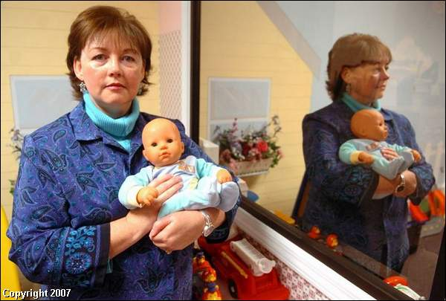
Dorothea Becker of the Family Nurturing Center uses this doll in her classes. She is in a supervised visitation room, which has a one-way mirror for social workers to watch parents with their children.
FLORENCE - It starts with a healthy, but inconsolable, crying baby and a frustrated parent or caregiver. It ends with a lifeless child or one left blind, brain damaged, paralyzed or developmentally delayed, who is likely to die by his or her fourth birthday.
It is shaken baby syndrome, and each year 1,200 to 1,400 cases are reported in the United States, according to the National Center on Shaken Baby Syndrome.
"The reported cases are the ones where the babies are so badly shaken they have to go to the hospital," said Dorothea Becker, education and prevention specialist for the Family Nurturing Center in Florence.
"We know it occurs and the babies are damaged, but it's not so severe that they have to go to the hospital."
SBS is just one form of child abuse that the Family Nurturing Center is working to stop.
Since 1979, the mission of the nonprofit agency has been to end child abuse by promoting individual well-being and healthy relationships in families and in the community.
Statistics from the Kentucky Cabinet for Health and Family Services indicate 6,737 reports of suspected child abuse or neglect in Northern Kentucky in 2005.
"It is a cycle of violence and abuse and neglect that is passed on from generation to generation and it's something that can end," Becker said.
The Family Nurturing Center provides counseling and education for families to establish healthy, functional relationships. It also offers community education and training to child-care providers, schools, parent associations and other community groups.
"They do so many things for abused children," said state Sen. Dick Roeding, R-Lakeside Park. "It can't be put in a nutshell."
He invited Becker to speak on behalf of the Family Nurturing Center at the Northern Kentucky Legislative Caucus meeting Feb. 24 in Erlanger.
"I just think that's so important and they do such great work out there for the community," Roeding said.
Becker and others at the center are working with partners across the community including St. Luke Hospital, St. Elizabeth Medical Center and Prevent Child Abuse Kentucky to prepare a resolution for the 2008 session of the Kentucky General Assembly to have mandatory SBS education in all 56 birthing hospitals in the commonwealth.
Becker said it is important for new mothers to realize that a crying, colicky baby can try even the best parent.
The legislation would push for parents to be educated on the dangers of shaking, for them to understand it is a severe problem that can destroy the entire family, and give tips on soothing their baby.
"You can't just tell them 'don't shake,' " Becker said.
"You have to tell them what to do instead, and the biggest thing is every family has to have a plan for what to do with an inconsolable baby."
Putting the baby down in a safe place, walking away and calling someone when a parent is too frustrated to deal with the child is essential to regain control of escalating emotions, according to Becker.
She noted that SBS not only affects infants, but children up to age 4. Because of immature neck muscles and a brain that hasn't grown to full capacity, they are also in greater danger of brain injury when violently shaken.
Becker also plans to meet with area school superintendents to discuss integrating child-abuse education programs into curriculum at the middle- and high-school levels.
The Family Nurturing Center is co-hosting a kickoff to Child Abuse Prevention Month at Tom Gill Chevrolet in Florence on April 3.
For more information on services and programs offered by the Family Nurturing Center, call 859-525-3200 or visit www.familynurture.org.
Friday, March 9th, 2007

